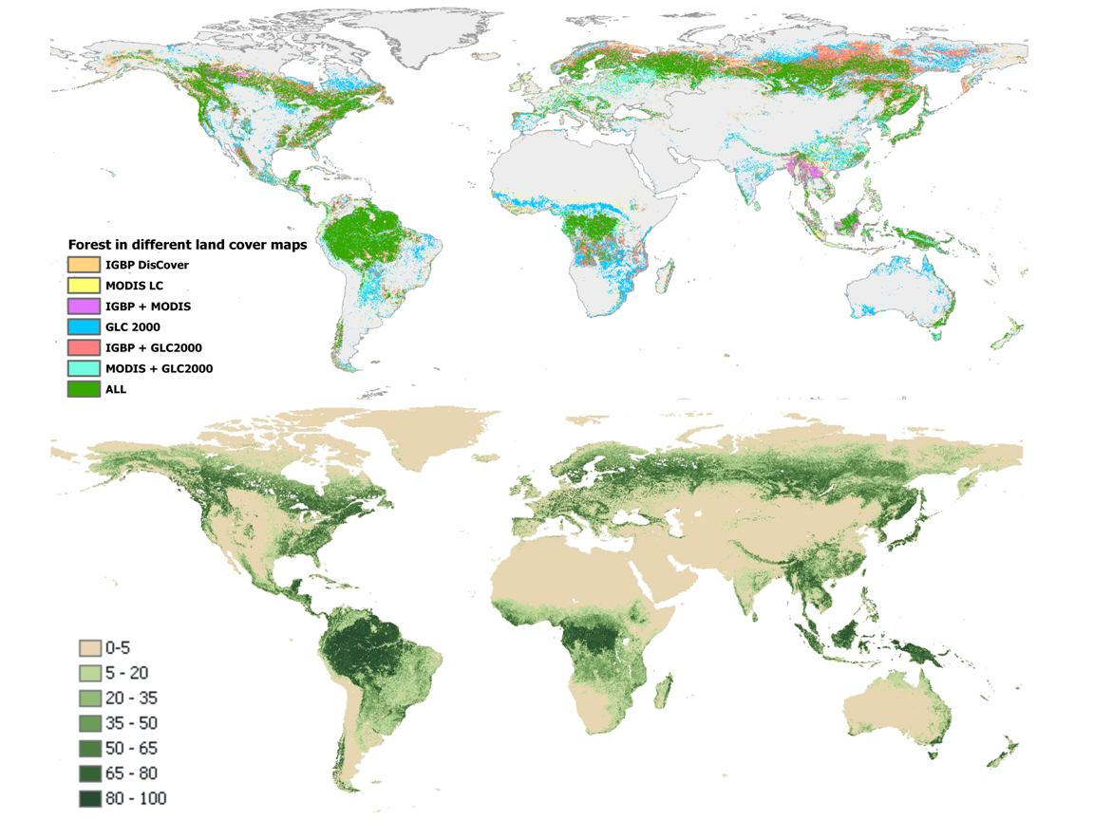
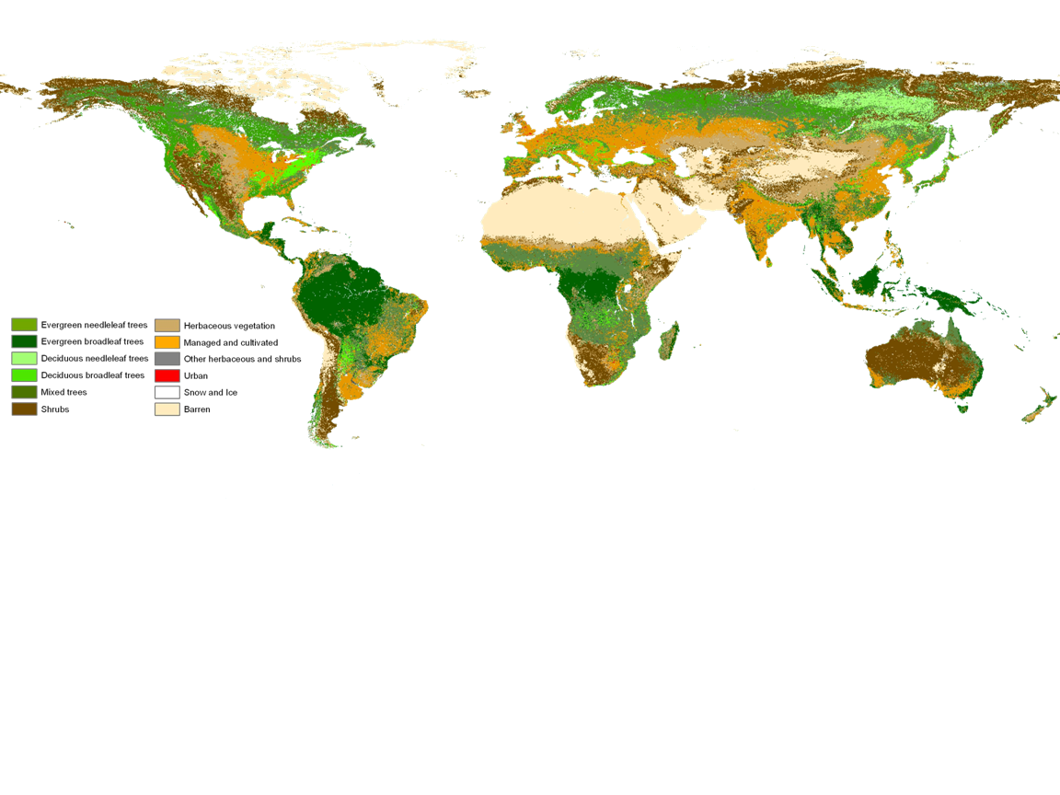
Global land cover
Forests in diff. maps
Percent tree cover
Objectives for the Community of Practice:

Provide a forum for communication and coordination of the teams involved in the GEO work plan tasks related to forest observations
Identify, gather, and seek agreement on user community requirements for forest observations, their present status and gaps to be filled
Advise the User Interface Committee, other CoPs and GEO on matters relating to forest observations and related societal benefits, and on cross-cutting issues of interest
Support the forest observation community with information about activities and plans in the GEO process
Global forest information from satellites: Heterogeneity of forest estimates in existing global land cover maps (top) limits their
usability. Percent tree canopy cover from MODIS (bottom).
Background
Terrestrial monitoring is currently the least operational Earth Observation component, compared to other parts of the earth system, such as the atmosphere and the oceans. With forests being an essential part of the terrestrial ecosystems, effective monitoring of forest ecosystems can strongly benefit from consistent, sustained, and integrated in situ and space-based observations. The benefits of integrated Earth Observation are numerous if adopted by forest user communities. There is large heterogeneity in the users of land observations whose needs are not fully articulated. The combination of remote and in situ observations has a great potential that is not yet fully realized. There is a need to develop an operational spaced based land observation framework, which contributes to the development of operational forest observation systems at national and global levels. The key earth observation challenges are observation continuity (satellite, in situ), data access issues (regional/national data sets, in situ), moving from research to operations given various user requirements, and capacity building and outreach.

A role for GEO
As evident from the GEO 10 year reference document, all societal benefit areas need information about the forests. GEO is the organization that is best suited to accomplish coordination among nations to develop a redundant and operational system of land observation satellites. Thus, GEO and its User Interface Committee (UIC), with the support of the UN-sponsored Global Observation of Forest and Land Cover Dynamics (GOFC-GOLD), have evolved a Community of Practice for forest observations (FCP) to respond to user requirements and to address the GEO Work Plan targets and its societal benefit areas. The FCP was officially established at the GEO II plenary in December 2005 and since then has worked on a number of objectives (see box).

Team
The initiating FCP team was based upon existing experiences and resources, led by Canada, Sweden, Finland, Germany and the Food and Agriculture Organization of the United Nations (FAO). GOFC-GOLD, a technical panel of the Global Terrestrial Observing System (GTOS) provides the administrative support for the FCP. Active FCP members include the co-leads of the GEO work plan tasks related to forests as described below.

Membership
Building a GEO Community of Practice for Forest Observations
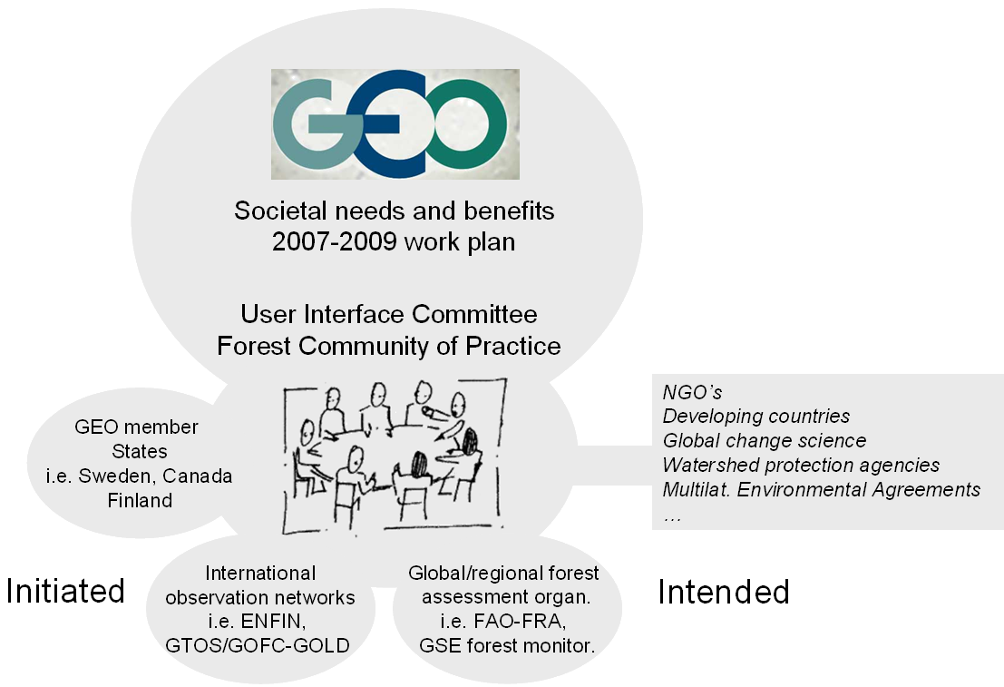
The intended membership for the FCP includes producers, developers and users of forest observations and observation systems. The membership is open, voluntary, and on a best efforts basis. Current key members are representatives from GEO member states (i.e. from Sweden, Canada, Finland), international observation networks (i.e. ENFIN and GTOS/GOFC-GOLD), active global and regional forest assessment organizations (i.e. FAO FRA and the European GSE forest monitoring). Additional members are from other countries and stakeholders, including NGO’s, and developing country representation through established networks. These include the eight GOFC-GOLD Regional Networks in Asia, Africa and Latin America.

How the CoP concept is implemented by the FCP
GEO’s Forests CoP focuses on actively fostering communication and coordination among the teams involved in GEO’s eight forest-related Tasks, which are enhancing observations and systems for forest mapping and monitoring of features such as cover, cover change, biomass and carbon, biodiversity, and fire disturbances. It is also encouraging registration of forest data, Earth observations, systems, and users in GEOSS. Finally, the FCP is advising GEO on matters relating to forest observations and related societal benefits and supporting the forest observation community with information about activities and plans in the GEO process. Active interaction are ongoing with the forest related GEO tasks including: Forest Mapping and Change Monitoring (AC-09-01e), Global Land Cover (DA-09-03a), Virtual Constellations-Land Surface Imaging (AR-09-02a), Global Fire Warning System (DI-09-03b), Key Observations for Climate-terrestrial (CL-09-02a), Regional Networks for Ecosystems (EC-09-01c), Communities of Practice-Forest (US-09-01b), and Forest Carbon Tracking (CL-09-03b).

Success in linking the GEO tasks to users of forest observations
FCP members have been connecting with the forest user community around the globe by actively participating in many workshops and meetings. Members have expressed interest in:

- Proceeding with the design of a global forest observations initiative (GFOI), an ambitious activity to which all eight GEO forest Tasks would contribute.
- Fostering better connection between remote sensing and ground-based observations.
- Collaborating with the Global Agriculture Monitoring CoP to fully address the Agriculture Societal Benefit Area.

The implementation progress of the FCP can be evaluated using several indicators. Active communication and regular teleconferences of the members and the success of workshops and outreach activities are essential. Another key success factor of the FCP is the strong linkage with GTOS/GOFC-GOLD, which is a well established coordination body for Earth observations and GEO participating organization. The thematic interests of GOFC-GOLD are well aligned with the eight GEO forest related tasks, while the regional networks provide effective links to forest observation users in developing regions of Asia, Africa and Latin America.

Additional information
Michael Brady, Canadian Forest Service/GOFC-GOLD: MBrady@NRCan.gc.ca; www.fao.org/gtos/gofc-gold

